UK CAR MANUFACTURING (data for February)
Hi-res charts available via Dropbox:
https://www.dropbox.com/sh/gqsi9ksd1hrqhb8/AACpcZUSMFdNjJciFWgPlhlZa?dl=0

UK car production steady in February, down -0.8%, as sector braces for coronavirus impact

- UK car production declines -0.8% in February, with some 1,033 fewer units made.
- Output for domestic market climbs 7.8% while exports fall -3.1% to 94,999, reflecting fundamentally sound sector despite global challenges.
- New initial impact analysis suggests coronavirus could wipe some 200,000 units off UK’s output in 2020, as sector urges government to accelerate access to emergency support for all businesses.

Friday 27 March, 2020 British car manufacturing fell -0.8% in February, according to figures released today by the Society of Motor Manufacturers and Traders (SMMT). Some 122,171 vehicles rolled off production lines in the month, representing a loss of just over 1,000 units compared with February 2019. The decline was driven by slower demand in some key global export markets.

In the month before the coronavirus pandemic started to be felt in the UK, global shipments fell -3.1% to just short of 95,000 units. Although combined EU demand rallied (up +3.6%), exports to the US and Asia fell substantially. Meanwhile, there was positive news for the domestic market, where output rose +7.8%, with 27,172 cars produced. Year-to-date figures show a -1.5% year-on-year drop in overall production.

The figures come at a time of unprecedented challenge for the UK and its automotive industry, with all car manufacturing plants now on shutdown as the country focuses efforts on overcoming the crisis. An initial assessment commissioned by SMMT of the potential impact of these shutdowns suggests a loss of around 200,000 units by the end of 2020, just under 1.1 million – a fall of 18%.¹ However, the impact could be far more severe if the crisis, and therefore shutdowns, were to last for months instead of weeks.

Mike Hawes, SMMT Chief Executive, said, “Despite the myriad global challenges the UK automotive industry has faced in recent times, it remains fundamentally strong and February’s figures reflect that. However, these figures also reflect the calm before the storm. With UK car plants now effectively on national shutdown and many global markets closed, the outlook is of deep concern. We wholeheartedly welcome government’s extraordinary package of emergency support for businesses and workers, but this must get through to businesses now. If we’re to keep this sector alive and in a position to help Britain get back on its feet, we urgently need funding to be released, additional measures to ease pressure on cashflow and clarity on how employment support measures will work.”

The automotive industry is one of the UK’s most valuable economic assets, contributing some £18.6 billion to the economy every year and employing hundreds of thousands of people across every region of the country in high-skilled, high-value jobs. Despite the current challenges, the entire industry stands ready to help the national effort, from production of essential medical equipment, to sustaining delivery of essential supplies, providing and maintaining emergency services vehicles and transporting key workers.

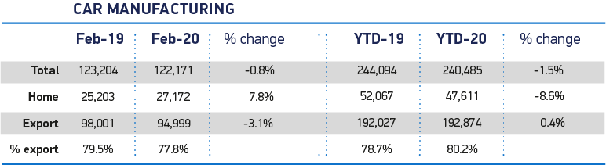

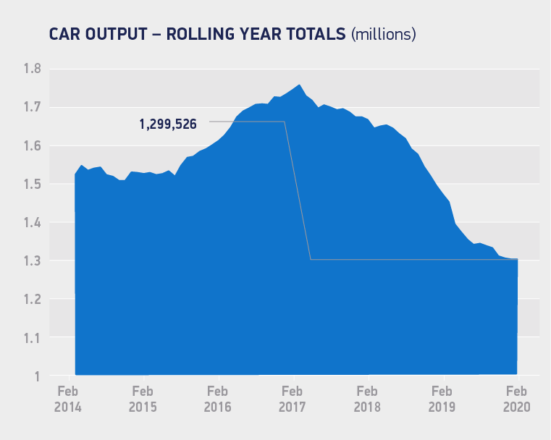

Notes to editors
1: Source - Auto Analysis – Based on the situation as of 16 March, 2020 and the assumption that the UK and the EU will conclude a trade deal; to come into effect on 1 January 2021 with zero tariffs and zero quotas for the automotive industry. The previous outlook for 2020, made in January, was 1.27m units.

About SMMT and the UK automotive industry

The Society of Motor Manufacturers and Traders (SMMT) is one of the largest and most influential trade associations in the UK. It supports the interests of the UK automotive industry at home and abroad, promoting a united position to government, stakeholders and the media.

The automotive industry is a vital part of the UK economy accounting for £82 billion turnover and £18.6 billion value added. With some 168,000 people employed directly in manufacturing and 823,000 across the wider automotive industry, it accounts for 14.4% of total UK export of goods and invests £3.75 billion each year in automotive R&D. More than 30 manufacturers build some 70 models of vehicle in the UK supported by 2,500 component providers and some of the world's most skilled engineers.

More detail on UK automotive available in SMMT's Motor Industry Facts 2019 publication at smmt.co.uk/facts19

Broadcasters: SMMT has an ISDN studio and access to expert spokespeople, case studies and regional representatives.

SMMT media contacts
Paul Mauerhoff, 020 7344 9233, pmauerhoff@smmt.co.uk
Aleona Krechetova, 020 7344 9215, akrechetova@smmt.co.uk
Emma Butcher, 020 7344 9263, ebutcher@smmt.co.uk

