UK COMMERCIAL VEHICLE MANUFACTURING

29 April 2021 (data for March 2021)

CV manufacturing up 16.9% in March, one year on from pandemic shuttering factories
- 6,166 vehicles manufactured in March, up 16.9% compared to lockdown-led factory shutdowns a year ago.
- March output remains significantly down on pre-pandemic levels, -32.2% on five-year average for the month.¹
- Domestic market sees bigger increase than overseas, as manufacturers adjust to new EU trading arrangements and grapple with renewed lockdown restrictions worldwide.

Thursday 29 April, 2021 UK commercial vehicle (CV) production increased by 16.9% in March, as 6,166 units left factory gates, according to the latest figures released today by the Society of Motor Manufacturers and Traders (SMMT). CV manufacturing saw its first month of growth since September 2020, marking the one-year anniversary since the coronavirus pandemic first caused plant closures in mid-March last year. However, output for the month remains significantly reduced on pre-pandemic levels, down -32.2% on a March average taken over the previous five years.
Production for both domestic and overseas markets saw an increase, with CVs destined for abroad experiencing a slower recovery, up 3.2% compared to 34.7% for the UK market. Renewed lockdown restrictions in other key markets and the added administrative burden of the new UK-EU trading arrangements with the EU took their toll on exports, amounting to less than half of all commercial vehicles built in the month for the first time since June 2020.² Performance over the first quarter has seen output fall -24.7% to 16,090 units, with some 5,264 fewer vehicles manufactured compared to this time last year.
Mike Hawes, SMMT Chief Executive, said, “One year since the coronavirus pandemic first caused a nationwide lockdown, we are starting to see signs of recovery, with growth in commercial vehicle production for the first time in six months being very welcome. March 2021 was always going to be up, as last year’s output was hit so badly by shuttered factories. While manufacturers are working hard to make up for production lost last year, getting back to pre-pandemic levels will take time as many LCV key export markets have new lockdown restrictions in place.
“Fleet renewal remains crucial to returning the CV sector to growth, especially as manufacturers are investing heavily in new zero emission capable technologies that support operator and driver needs. The pace of this transformation can also ensure the UK remains an attractive and globally competitive destination for commercial vehicle manufacturing.”

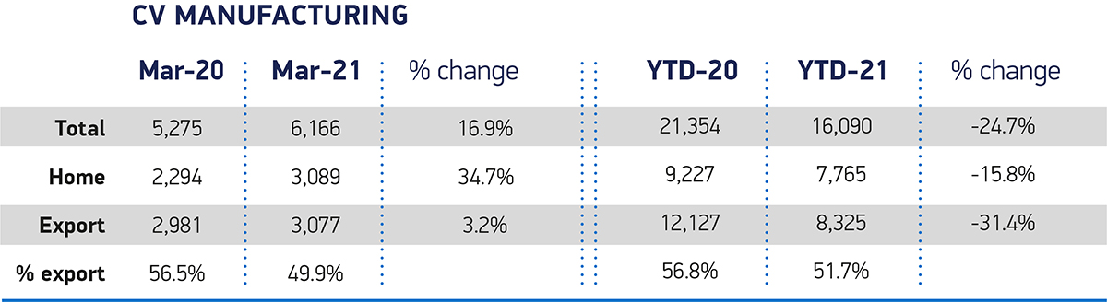

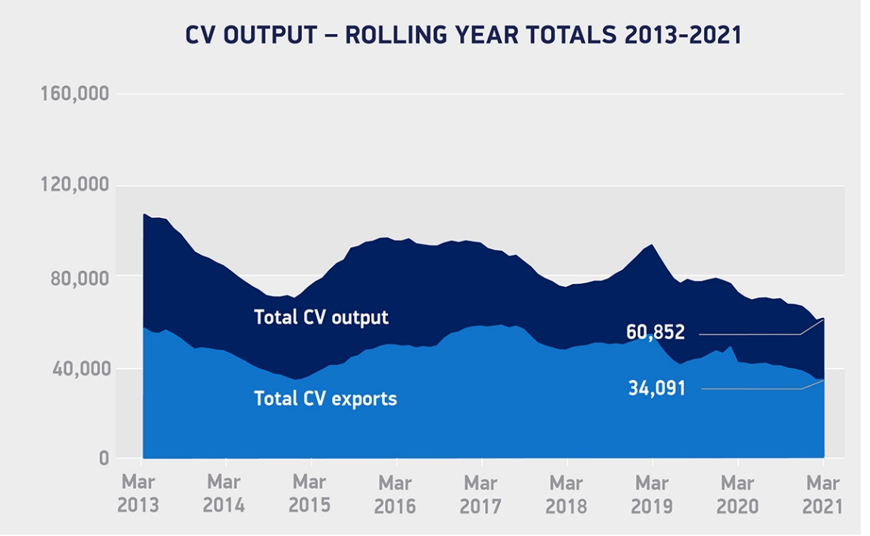

Notes to editors
- 2015-2019 average – 8,492
- June 2020 – 48.3% export

High-res charts can be downloaded here: https://www.dropbox.com/sh/3typj5qc3pkal52/AAD--us9XavaIlpXrrhrvV4Ta?dl=0

About SMMT and the UK automotive industry

The Society of Motor Manufacturers and Traders (SMMT) is one of the largest and most influential trade associations in the UK. It supports the interests of the UK automotive industry at home and abroad, promoting a united position to government, stakeholders and the media.

The automotive industry is a vital part of the UK economy accounting for £78.9 billion turnover and £15.3 billion value added. With some 180,000 people employed directly in manufacturing and 864,000 across the wider automotive industry, it accounts for 13% of total UK export of goods and invests more than £3 billion each year in automotive R&D. More than 30 manufacturers build some 70 models of vehicle in the UK supported by 2,500 component providers and some of the world's most skilled engineers.

More detail on UK automotive available in SMMT's Motor Industry Facts 2020 publication at smmt.co.uk/facts20

Broadcasters: SMMT has an ISDN studio and access to expert spokespeople, case studies and regional representatives.

Media contacts:

Paul Mauerhoff 07809 522181 pmauerhoff@smmt.co.uk
James Boley 07927 668565 jboley@smmt.co.uk
Aleona Krechetova 07912 799959 akrechetova@smmt.co.uk
Daniel Zealander 07546 415205 dzealander@smmt.co.uk
Karen Parry 07708 480889 kparry@smmt.co.uk

