UK CAR MANUFACTURING (data for July)
Strictly embargoed until 00:01, Thursday 26 August 2021
Hi-res charts available via Dropbox:
https://www.dropbox.com/sh/igivrxzat9tdpvw/AACRrVlEOs7nSR4Qxatqejkha?dl=0

UK car production plummets in July

- British car manufacturing output declines -37.6% in July with 53,438 units made.
- Production volumes damaged by global chip shortages, ‘pingdemic’ and summer shutdown timings.
- 26.0% of all cars made in July were alternatively fuelled, their highest share on record.

Thursday 26 August, 2021 UK car manufacturing output fell -37.6% in July, the first fall since February, with just 53,438 units made, according to the latest figures released today by the Society of Motor Manufacturers and Traders (SMMT). It represented the worst July performance since 1956 as manufacturers grappled with the global shortage of semiconductors and staff absence resulting from the ‘pingdemic’, with some altering summer shutdown timings to help manage the situation.¹

In July production for the UK market declined -38.7% to 8,233 while manufacturing for export also fell, down -37.4% with 45,205 cars shipped overseas. Exports accounted for more than eight out of 10 (84.6%) vehicles built in the month as buyers around the world continued to be attracted to the wide range of high-quality cars made in Britain, including the latest alternatively fuelled models.

More than a quarter (26.0%) of all cars made in July were either battery electric (BEV), plug in hybrid (PHEV) or hybrid electric (HEV), their highest share on record, and meaning that UK car factories have turned out 126,757 of these important products since the start of the year.

Production overall remains up 18.3% on Covid hit 2020 at 552,361 units, but this is down significantly (-28.7%) on 2019 pre-pandemic levels when 774,760 cars rolled off production lines.

Mike Hawes, SMMT Chief Executive, said, “These figures lay bare the extremely tough conditions UK car manufacturers continue to face. While the impact of the ‘pingdemic’ will lessen as self-isolation rules change, the worldwide shortage of semiconductors shows little sign of abating. The UK automotive industry is doing what it can to keep production lines going, testament to the adaptability of its workforce and manufacturing processes, but Government can help by continuing the supportive Covid measures currently in place and boosting our competitiveness with a reduction in energy levies and business rates for a sector that is strategically important in delivering net zero.”

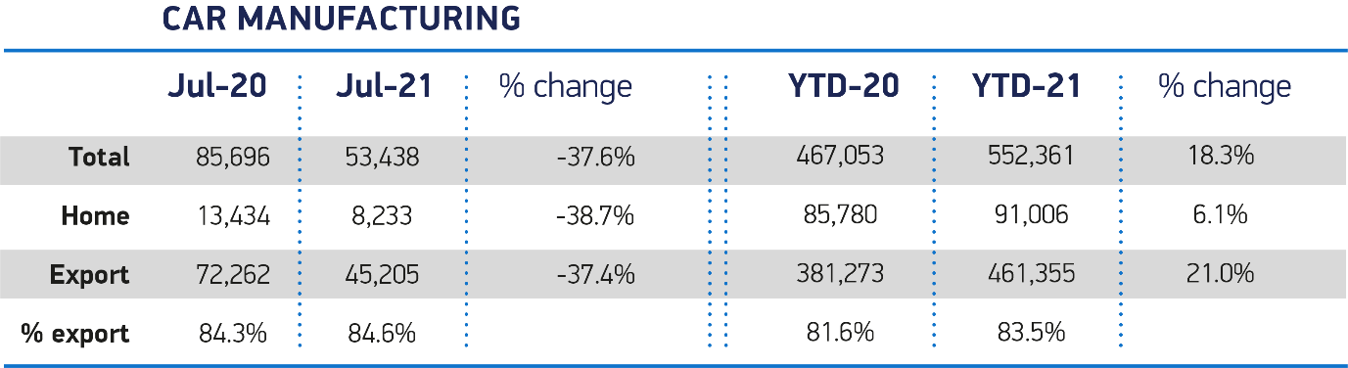

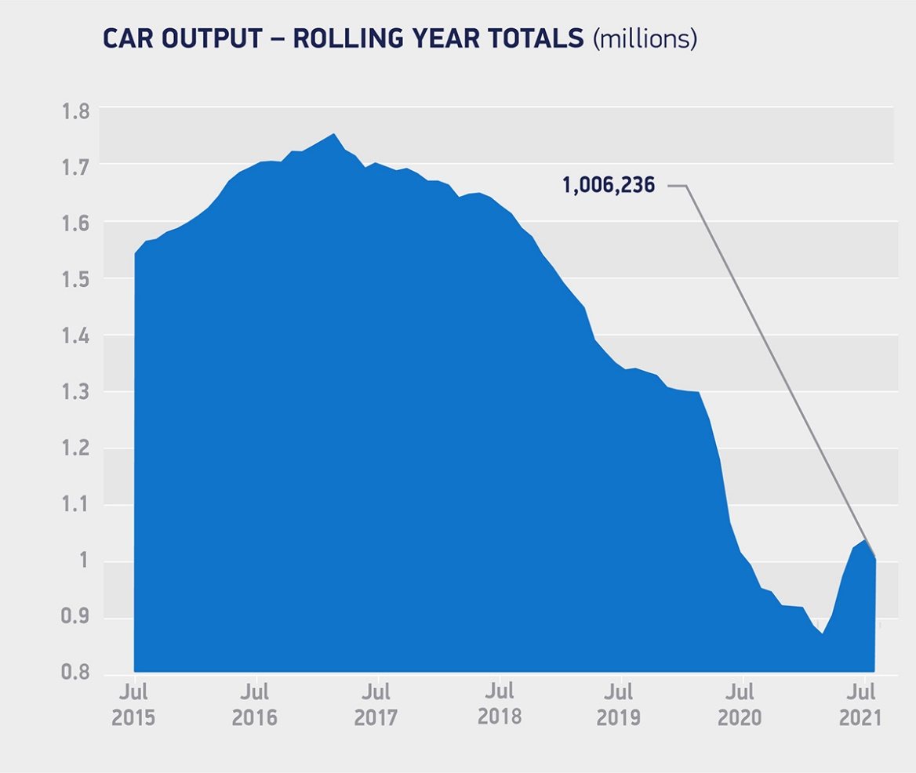

Notes to editors

1: July 1956 - 51,472 cars produced

About SMMT and the UK automotive industry

The Society of Motor Manufacturers and Traders (SMMT) is one of the largest and most influential trade associations in the UK. It supports the interests of the UK automotive industry at home and abroad, promoting a united position to government, stakeholders and the media.

The automotive industry is a vital part of the UK economy accounting for £78.9 billion turnover and £15.3 billion value added. With some 180,000 people employed directly in manufacturing and 864,000 across the wider automotive industry, it accounts for 13% of total UK export of goods and invests more than £3 billion each year in automotive R&D. More than 30 manufacturers build some 70 models of vehicle in the UK supported by 2,500 component providers and some of the world's most skilled engineers.

More detail on UK automotive available in SMMT's Motor Industry Facts 2020 publication at smmt.co.uk/facts20

Broadcasters: SMMT has an ISDN studio and access to expert spokespeople, case studies and regional representatives.

Media contacts:

Paul Mauerhoff 07809 522181 pmauerhoff@smmt.co.uk
James Boley 07927 668565 jboley@smmt.co.uk
Daniel Zealander 07546 415205 dzealander@smmt.co.uk
Karen Parry 07708 480889 kparry@smmt.co.uk

