UK ENGINE MANUFACTURING

30 September 2021 (data for August 2021)

Engine production falls -23.6% in August

- UK factories made 81,266 engines last month, a decline of -23.6% over a Covid-19 impacted August 2020.
- Demand from both domestic and export markets falls by -27.0% and -21.8% respectively.
- Year-to-date engine manufacturing increases by 3.9% to 1,140,058 units compared to 2020 but remains
-33.0% below the five-year average.¹

Mike Hawes, SMMT Chief Executive, said, “Further declines in engine production in August are very worrying when viewed in context against last year, when lockdowns and depressed global demand stalled output. However, the worldwide shortage of semiconductors – itself caused by Covid issues globally - continues to throttle vehicle production, putting automotive jobs and livelihoods at risk. It is vital that government take urgent action, such as extending coronavirus job support schemes, and introducing measures to improve competitiveness to assist the sector.”

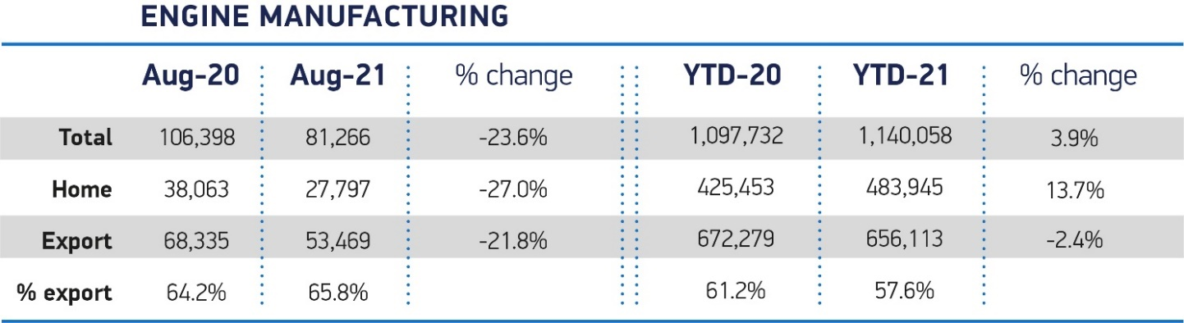

Notes to editors
1 2015-2019 average for January-August is 1,702,714 units

High-res charts can be downloaded here: https://www.dropbox.com/sh/p0rzrqj2lieo7e2/AABh6am8gtLkPa3vl6ouw9ACa?dl=0

About SMMT and the UK automotive industry

The The Society of Motor Manufacturers and Traders (SMMT) is one of the largest and most influential trade associations in the UK. It supports the interests of the UK automotive industry at home and abroad, promoting the industry to government, stakeholders and the media.

The automotive industry is a vital part of the UK economy, and integral to supporting the delivery of the agendas for levelling up, net zero, advancing global Britain, and the plan for growth. It contributes £60 billion turnover and £12 billion value added to the UK economy, and invests around £3 billion each year in R&D. With more than 155,000 people employed directly in manufacturing and some 800,000 across the wider automotive industry, it accounts for 11% of total UK exports with more than 150 countries importing UK produced vehicles, generating more than £73 billion of trade.

More than 30 manufacturers build more than 70 models of vehicle in the UK, supported by more than 2,500 component providers and some of the world's most skilled engineers. The automotive sector also supports jobs in other key sectors – including advertising, chemicals, finance, logistics and steel. Many of these jobs are outside London and the South East, with wages that are around 25% higher than the UK average.

More detail on UK automotive available in SMMT's Motor Industry Facts 2021 publication at smmt.co.uk/facts21

Broadcasters: SMMT has an ISDN studio and access to expert spokespeople, case studies and regional representatives.

Media contacts:

Paul Mauerhoff 07809 522181 pmauerhoff@smmt.co.uk
James Boley 07927 668565 jboley@smmt.co.uk
Daniel Zealander 07546 415205 dzealander@smmt.co.uk
Karen Parry 07708 480889 kparry@smmt.co.uk

