UK CAR MANUFACTURING (data for November)
Strictly embargoed until 00:01, Thursday 23 December 2021
Hi-res charts available via Dropbox: https://www.dropbox.com/sh/zmsvk3eu42y4pj0/AACz8Oy555_zmuLRVuPot0kHa?dl=0

Output falls -28.7% despite electric vehicle boost

- UK car manufacturing output declines -28.7% in November with 75,756 cars leaving factory gates.
- Production for domestic and overseas markets falls -18.8% and -30.4% respectively.
- Battery electric vehicle output surges 52.9% in November, to reach record 13.7% share.
- Sector broadly prepared for full UK-EU customs controls on 1 January but nervousness remains.

Thursday 23 December, 2021 UK car production fell -28.7% in November to 75,756 units, according to the latest figures released today by the Society of Motor Manufacturers and Traders (SMMT). It was the fifth consecutive month of decline and represents the worst November performance since 1984 as UK car makers continue to wrestle with the worldwide shortage of semiconductors. The figures also reflect the loss of output arising from the closure of a UK car factory in the summer, a situation that will impact year-on-year comparisons until July 2022.

In November production for both domestic and overseas markets declined, down -18.8% and -30.4% respectively, as 30,487 fewer cars rolled off factory lines. Exports accounted for more than 80% of all cars produced last month, reinforcing the need for smooth international trade, especially with the EU, as new customs controls with the bloc come into effect on 1 January 2022. Six-in-ten (60.3%) cars shipped overseas in November headed into Europe. Asia, meanwhile, took 15.6% of UK car exports, the US 13.4% and Australia 1.2%.

Continuing the recent trend, British production of battery electric, plug-in hybrid and hybrid cars took a record share of production, accounting for around a third (32.7%) of all cars made in the month, and more than a quarter (25.5%) over the year-to-date. Battery electric vehicle output, in particular, was up in November by 52.9% to 10,359 units, hitting a new high of 13.7% of all production, more than double the level a year ago.

Year-to-date, UK car plants have turned out 797,261 units, some 432,794 less than pre-pandemic 2019 and 667,441 off the five-year pre-Covid average for the period of 1,464,702 cars.

Mike Hawes, SMMT Chief Executive, said, “These are incredibly worrying figures, underscoring the severity of situation facing the automotive industry. Covid is impacting supply chains massively, causing global shortages - especially of semiconductors - which is likely to affect the sector throughout next year. With an increasingly negative economic backdrop, rising inflation and Covid resurgence at home and abroad, the circumstances are the toughest in decades. With output massively down for the past five months and likely to continue, maintaining cashflow, especially in the supply chain, is of vital importance. We have to look to Government to provide support measures in the same way it is recognising other Covid-impacted sectors.

“The industry is as well prepared as it can be for the implementation of full customs controls at UK borders from 1 January but any delays arising from ill-prepared freight or systems will place further stress on automotive businesses that operate ‘just in time’. Should any problems arise, contingency measures must be implemented immediately to keep cross border trade flowing smoothly.”

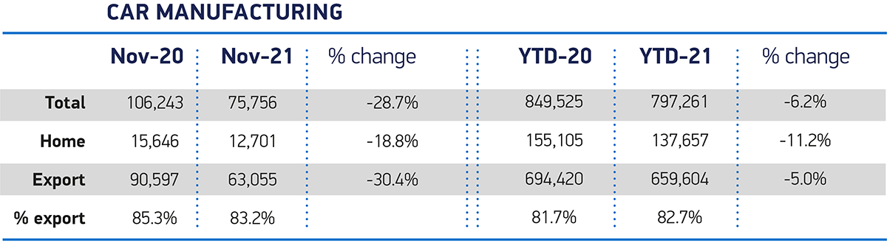

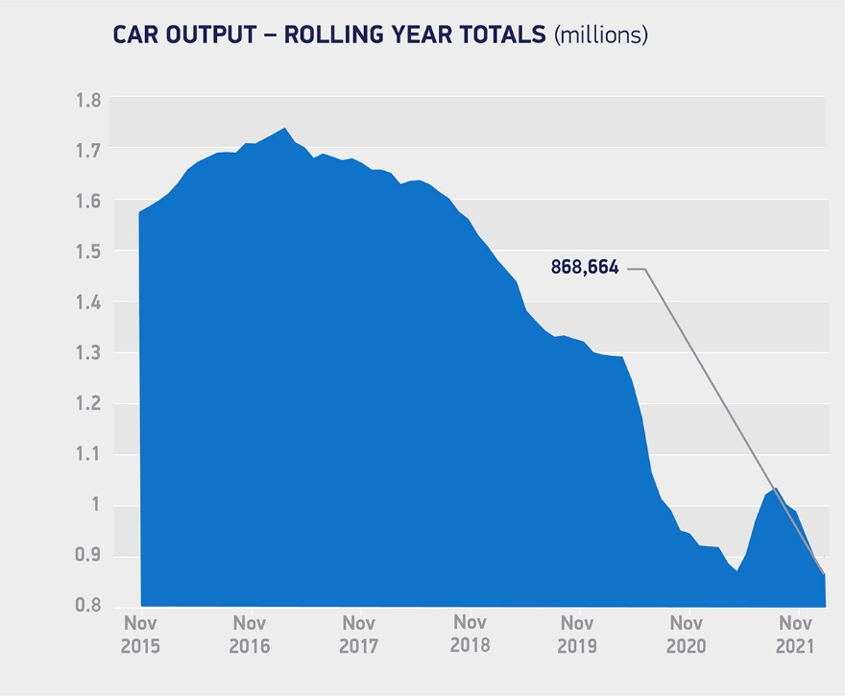
Notes to editors

1 UK car production November 1984 - 71,531 units.

About SMMT and the UK automotive industry

The Society of Motor Manufacturers and Traders (SMMT) is one of the largest and most influential trade associations in the UK. It supports the interests of the UK automotive industry at home and abroad, promoting the industry to government, stakeholders and the media.

The automotive industry is a vital part of the UK economy, and integral to supporting the delivery of the agendas for levelling up, net zero, advancing global Britain, and the plan for growth. It contributes £60 billion turnover and £12 billion value added to the UK economy, and invests around £3 billion each year in R&D. With more than 155,000 people employed directly in manufacturing and some 800,000 across the wider automotive industry, it accounts for 11% of total UK exports with more than 150 countries importing UK produced vehicles, generating more than £73 billion of trade.

More than 30 manufacturers build more than 70 models of vehicle in the UK, supported by more than 2,500 component providers and some of the world's most skilled engineers. The automotive sector also supports jobs in other key sectors – including advertising, chemicals, finance, logistics and steel. Many of these jobs are outside London and the South-East, with wages that are around 25% higher than the UK average.

More detail on UK automotive available in SMMT's Motor Industry Facts 2021 publication at smmt.co.uk/facts21

Broadcasters: SMMT has an ISDN studio and access to expert spokespeople, case studies and regional representatives.

SMMT media contacts
Paul Mauerhoff 07809 522181 pmauerhoff@smmt.co.uk
James Boley 07927 668565 jboley@smmt.co.uk
Daniel Zealander 07546 415205 dzealander@smmt.co.uk
Scott Clarke 020 7344 9215 sclarke@smmt.co.uk
Karen Parry 07708 480889 kparry@smmt.co.uk

