UK ENGINE MANUFACTURING
28 April 2022 (data for March 2022)
UK engine production declines -22.7% in March
- March engine output declines -22.7%, to 152,250 units.
- Production for UK and overseas markets falls -27.2% and -19.0% respectively in the month.
- 411,273 engines built in first quarter, down -23.2% on Q1 2021.

Mike Hawes, SMMT Chief Executive, said, “While the automotive industry is resilient, the global shortage of semiconductors, has affected both vehicle and engine production. The competitiveness of the industry is also being challenged by the rising cost of energy and other inflationary pressures here and abroad. For the industry to recover, it urgently needs government action, including measures to reduce business costs which will help ensure that the UK remains at the forefront of automotive manufacturing and protect the jobs and livelihoods of its skilled workers.”

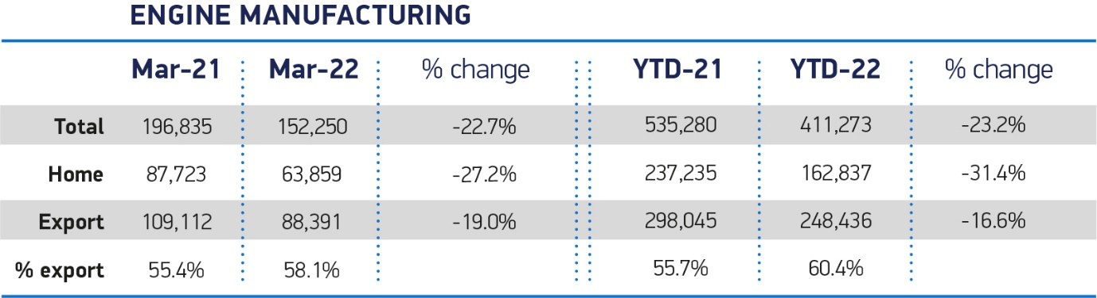
Notes to Editors
Hi-res charts available here: https://www.dropbox.com/sh/zrrxeoafrxxae1v/AADylJbGgmm3PzdC88xP7v2Ba?dl=0
About SMMT and the UK automotive industry
The Society of Motor Manufacturers and Traders (SMMT) is one of the largest and most influential trade associations in the UK. It supports the interests of the UK automotive industry at home and abroad, promoting the industry to government, stakeholders and the media.
The automotive industry is a vital part of the UK economy, and integral to supporting the delivery of the agendas for levelling up, net zero, advancing global Britain, and the plan for growth. It contributes £60 billion turnover and £12 billion value added to the UK economy, and invests around £3 billion each year in R&D. With more than 155,000 people employed directly in manufacturing and some 800,000 across the wider automotive industry, it accounts for 11% of total UK exports with more than 150 countries importing UK produced vehicles, generating more than £73 billion of trade.
More than 30 manufacturers build more than 70 models of vehicle in the UK, supported by more than 2,500 component providers and some of the world's most skilled engineers. The automotive sector also supports jobs in other key sectors – including advertising, chemicals, finance, logistics and steel. Many of these jobs are outside London and the South-East, with wages that are around 25% higher than the UK average.
More detail on UK automotive available in SMMT's Motor Industry Facts 2021 publication at smmt.co.uk/facts21
Broadcasters: SMMT has an ISDN studio and access to expert spokespeople, case studies and regional representatives.
SMMT media contacts
Paul Mauerhoff 07809 522181 pmauerhoff@smmt.co.uk
James Boley 07927 668565 jboley@smmt.co.uk
Daniel Zealander 07546 415205 dzealander@smmt.co.uk
Scott Clarke 07912 799959 sclarke@smmt.co.uk
Emma Butcher 07880 191825 ebutcher@smmt.co.uk

