SMMT USED CAR SALES (data for Q1 2022)
Strictly embargoed until 00.01, Tuesday 10 May 2022
Hi-res charts available via Dropbox: https://www.dropbox.com/sh/2pl5i7u3osikzot/AADyAKeRj7vlp65CFg4gzLx7a?dl=0

Used car buyers double up on electric vehicles as market grows 5.1%

- UK used car market grows 5.1% in Q1 2022 with 1,774,351 cars changing hands.
- Sales up in January (17.7%) and February (7.4%), but down in March (-6.8%).
- Market for used BEVs more than doubles, up 120.2% marking a record Q1 for transactions.

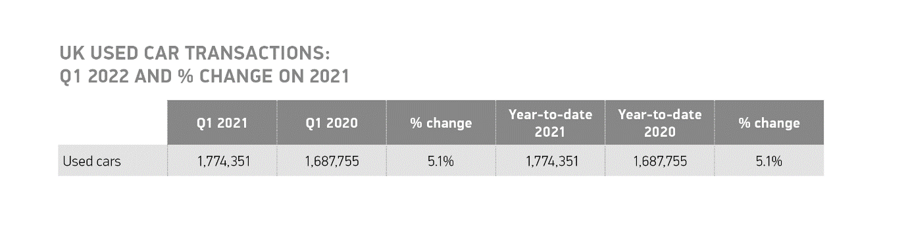
Tuesday 10 May, 2022 The UK’s used car market increased 5.1% in the first quarter of 2022, according to the latest figures released today by the Society of Motor Manufacturers and Traders (SMMT). Some 1,774,351 transactions took place, with 86,596 additional cars changing hands compared with the same period in 2021, when car showrooms nationwide were closed due to pandemic-related lockdowns with only click and collect transactions allowed.¹

Despite the global shortage of semiconductors stifling supply in the new car market, used car sales in the quarter were driven by a buoyant market in January and February, with rises of 17.7% and 7.4% respectively. March, on the other hand, saw a decline of -6.8%, following a stronger performing month in 2021 as the pandemic-affected market began to recover. Despite growth over the course of the quarter, used car transactions remain -12.2% below the pre-pandemic year of 2019.²

It was a record first quarter for used battery electric vehicles (BEVs), with buyers keen to purchase pre-owned zero-emission cars. Transactions for BEVs more than doubled from 6,625 to 14,586, a rise of 120.2%. Plug in hybrids (PHEVs) and hybrids (HEVs) also changed hands in greater numbers than the year before rising by 35.3% to 14,433, and 28.8% to 35,007 units respectively.

Despite the growth, however, petrol and diesel powertrains continued to dominate the used market representing 96.2% of used sales, or some 1,707,135 units. Plug-in vehicles comprised 3.6% of the total market share – up from 1.6% in Q1 2021, but illustrating that the growth in new EVs over the past two years has yet to have a significant impact on the overall market.

Mini, dual purpose and supermini segments saw the largest growth, up 13.5%, 12.3% and 9.1% respectively. MPV transactions, meanwhile, declined by -7.5%, followed by luxury saloons (-3.4%) and upper mediums (-3.0%). Superminis (32.6%) remained the most popular used buy, followed by lower medium (26.6%) and dual purpose (14.0%), with these three segments accounting for more than seven in 10 (73.2%) of all cars finding new owners.

Black was the most popular colour choice, with one in five cars changing hands painted in the colour, some 383,418 units, followed by blue and silver/aluminium. At the other end of the spectrum, just 1,184 pink cars filtered through to second owners.³

Mike Hawes, SMMT Chief Executive, said, “With the new car market hampered by ongoing global supply shortages, growth in the used car market is welcome, if unsurprising especially given we were in lockdown last year. Electric car sales are energising the market, with zero emission vehicles starting to filter through in larger numbers to consumers looking forward to driving the latest and greenest vehicles. Although there is some way to go before we see the recent growth in new EVs replicated in the used market, a buoyant new car market will be vital to help drive fleet renewal which is essential to the delivery of carbon savings.”

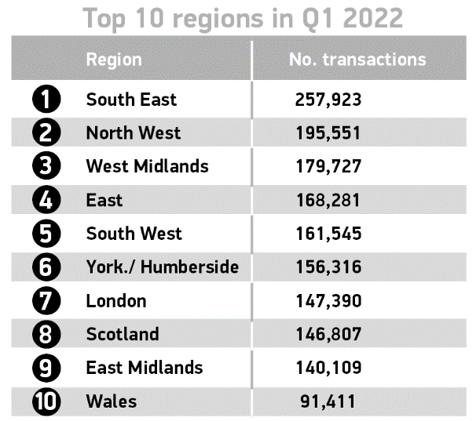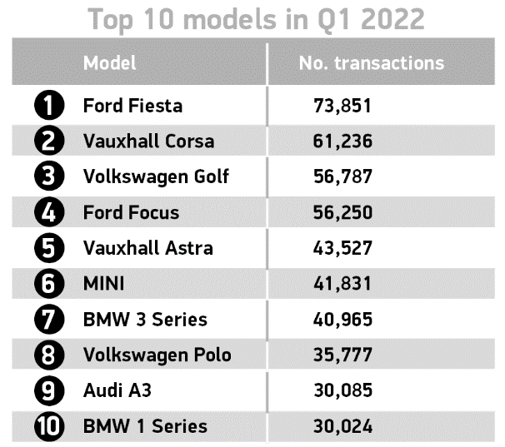
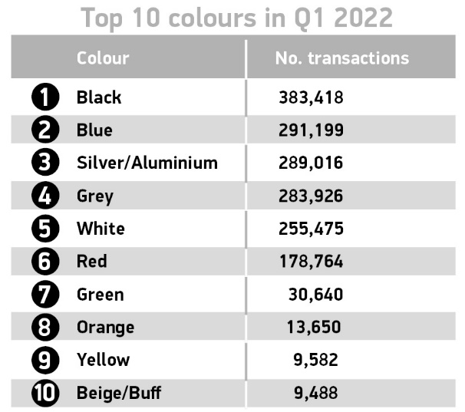

Notes to editors:

1: Q1 2021: 1,687,755
2: Q1 2019: 2,020,144
3: https://media.smmt.co.uk/new-car-colours-2021/#:~:text=At%20the%20niche%20end%20of,of%20the%20market%20(0.9%25).

About SMMT and the UK automotive industry

The Society of Motor Manufacturers and Traders (SMMT) is one of the largest and most influential trade associations in the UK. It supports the interests of the UK automotive industry at home and abroad, promoting the industry to government, stakeholders and the media.

The automotive industry is a vital part of the UK economy, and integral to supporting the delivery of the agendas for levelling up, net zero, advancing global Britain, and the plan for growth. It contributes £60 billion turnover and £12 billion value added to the UK economy, and invests around £3 billion each year in R&D. With more than 155,000 people employed directly in manufacturing and some 800,000 across the wider automotive industry, it accounts for 11% of total UK exports with more than 150 countries importing UK produced vehicles, generating more than £73 billion of trade.

More than 30 manufacturers build more than 70 models of vehicle in the UK, supported by more than 2,500 component providers and some of the world's most skilled engineers. The automotive sector also supports jobs in other key sectors – including advertising, chemicals, finance, logistics and steel. Many of these jobs are outside London and the South-East, with wages that are around 25% higher than the UK average.

More detail on UK automotive available in SMMT's Motor Industry Facts 2021 publication at smmt.co.uk/facts21

Broadcasters: SMMT has an ISDN studio and access to expert spokespeople, case studies and regional representatives.

Media contacts:

Paul Mauerhoff 07809 522181 pmauerhoff@smmt.co.uk
James Boley 07927 668565 jboley@smmt.co.uk
Daniel Zealander 07546 415205 dzealander@smmt.co.uk
Scott Clarke 07912 799959 sclarke@smmt.co.uk
Emma Butcher 07880 191825 ebutcher@smmt.co.uk

