UK COMMERCIAL VEHICLE MANUFACTURING
28 July 2022 (data for June and H1 2022)
Hi-res charts available via Dropbox: https://www.dropbox.com/sh/v24xsaino5v5liv/AACQcy2D7wqISZ8AekHO1Vcea?dl=0
UK CV production grows 64.4% in June to round off best first half in a decade
- UK commercial vehicle production grows 64.4% in June, with 9,549 units leaving British factory lines.
- Year-to-date output increases 47.4%, resulting in best first six months to a year since 2012.
- CV manufacturers show resilience but urgent action is needed to protect UK competitiveness.

Thursday 28 July, 2022 UK commercial vehicle (CV) production grew 64.4% in June with 9,549 units leaving British factory lines, according to the latest figures released today by the Society of Motor Manufacturers and Traders (SMMT). June production volumes were the highest since 2015 and 32.7% above the pre-pandemic five-year average,¹ resulting in the sector’s sixth consecutive month of increased output.

Growth has largely been driven by overseas demand, with exports of British-built CVs jumping 133.0% year on year in June – now representing nearly six in 10 (58.1%) units – with some 92.5% of exports destined for the EU. Domestic demand, which remained more robust during the pandemic last year, increased by 16.7%, with year-on-year growth in four out of six months in 2022.

The strong performance means total output in the year to date reached 50,596 units, up 47.4% on 2021 and 16.6% above the pre-pandemic five-year average.² As a result, output from January to June was the highest since 2012, as CV manufacturers ensure there is capacity to build these critical vehicles amid a boom in demand from businesses and operators renewing their fleets.

The UK’s commercial vehicle sector has been a consistent bright spot amid the gloom experienced by the automotive industry. Its global competitiveness is, however, not guaranteed. It is crucial that inflation and energy costs are tackled with urgency, particularly as manufacturers continue to invest in production of the latest zero emission vehicles.

Mike Hawes, SMMT Chief Executive, said, “The CV sector’s best first half performance in a decade is evidence of its resilience, as manufacturers strive to ensure orders for these vehicles, which are critical to the UK economy, are delivered in a highly challenging economic environment. At the same time, manufacturers are committed to building a growing range of more fuel efficient and zero emission vans, trucks, buses, coaches and taxis, an essential step towards achieving Net Zero, while ensuring society can continue to move. We must protect the global competitiveness of the sector amid these challenges, however, starting with measures to tackle energy costs, so that the UK continues to be among the world’s leading manufacturers for these vital vehicles.”

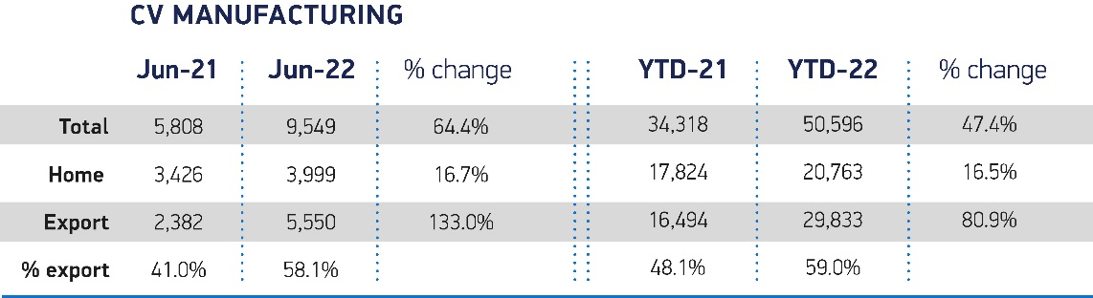

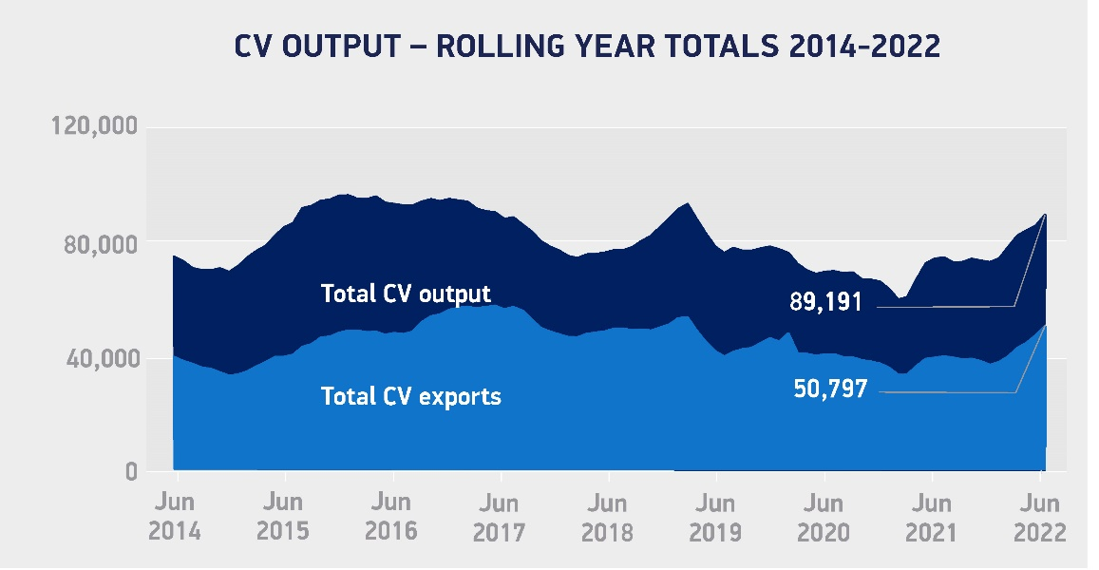

Notes to editors

¹ Pre-pandemic five-year average for June: 7,199 units.
² Pre-pandemic five-year average for January-June: 43,391 units.

About SMMT and the UK automotive industry

The automotive industry is a vital part of the UK economy and integral to supporting the delivery of the agendas for levelling up, net zero, advancing global Britain, and the plan for growth.

Automotive-related manufacturing contributes £67 billion turnover and £14 billion value added to the UK economy, and typically invest around £3 billion each year in R&D. With more than 182,000 people employed in manufacturing and some 780,000 in total across the wider automotive industry, we account for 10% of total UK goods exports with more than 150 countries importing UK produced vehicles, generating £77 billion of trade.

More than 25 manufacturers build over 70 models of vehicles in the UK, plus an array of specialist small volume manufacturers, supported by some 5,000 supply chain businesses and some of the world's most skilled engineers. Many of these jobs are outside London and the Southeast, with wages that are around 14% higher than the UK average. The automotive sector also supports jobs in other key sectors – including advertising, finance and logistics.

More detail on UK automotive available in SMMT's Motor Industry Facts publication at www.smmt.co.uk/reports/smmt-motor-industry-facts/

Broadcasters: SMMT has an ISDN studio and access to expert spokespeople, case studies and regional representatives.

Media contacts

Paul Mauerhoff 07809 522181 pmauerhoff@smmt.co.uk
James Boley 07927 668565 jboley@smmt.co.uk
Daniel Zealander 07546 415205 dzealander@smmt.co.uk
Scott Clarke 07912 799959 sclarke@smmt.co.uk
Emma Butcher 07880 191825 ebutcher@smmt.co.uk

