UK ENGINE MANUFACTURING
UK engine production down -12.7% in first half of 2022
- Engine production declines -12.7% in first six months of 2022, totalling 812,397 units.
- Year to date output for export falls -9.7%, while production for the UK is down -16.4%.
- Measures to reduce business costs, including energy, must be a priority to protect UK competitiveness and jobs.

Mike Hawes, SMMT Chief Executive, said, “The global shortage of semiconductors continues to wreak havoc on the production of vehicles and, in turn, engines, with manufacturers operating in a highly challenging economic environment. To ensure the UK is an attractive place to invest, however, key competitiveness issues such as business costs, not least energy, must be tackled to safeguard the skilled jobs that make a huge contribution to the British economy.”

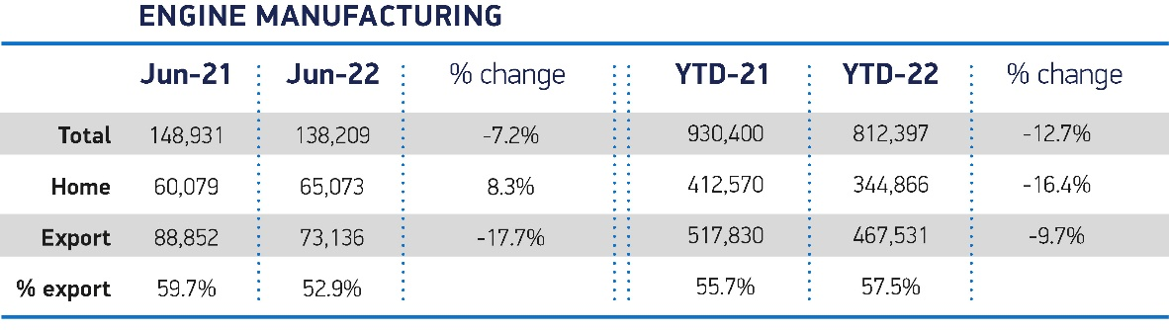

Notes to editors

About SMMT and the UK automotive industry

The automotive industry is a vital part of the UK economy and integral to supporting the delivery of the agendas for levelling up, net zero, advancing global Britain, and the plan for growth.

Automotive-related manufacturing contributes £67 billion turnover and £14 billion value added to the UK economy, and typically invest around £3 billion each year in R&D. With more than 182,000 people employed in manufacturing and some 780,000 in total across the wider automotive industry, we account for 10% of total UK goods exports with more than 150 countries importing UK produced vehicles, generating £77 billion of trade.

More than 25 manufacturers build over 70 models of vehicles in the UK, plus an array of specialist small volume manufacturers, supported by some 5,000 supply chain businesses and some of the world's most skilled engineers. Many of these jobs are outside London and the Southeast, with wages that are around 14% higher than the UK average. The automotive sector also supports jobs in other key sectors – including advertising, finance and logistics.

More detail on UK automotive available in SMMT's Motor Industry Facts publication at www.smmt.co.uk/reports/smmt-motor-industry-facts/

Broadcasters: SMMT has an ISDN studio and access to expert spokespeople, case studies and regional representatives.

Media contacts

Paul Mauerhoff 07809 522181 pmauerhoff@smmt.co.uk
James Boley 07927 668565 jboley@smmt.co.uk
Daniel Zealander 07546 415205 dzealander@smmt.co.uk
Scott Clarke 07912 799959 sclarke@smmt.co.uk
Emma Butcher 07880 191825 ebutcher@smmt.co.uk

